EXP 7 K MANOJ KIRAAN
240701305

Creating User Roles and Configuring Permissions in Zoho Creator

Aim
To create different user roles in Zoho Creator and configure appropriate permissions for each role to control access to the Student Management System.

Procedure
- Open the Student Management System application in Zoho Creator.
- Navigate to Users and Control → Roles.
- Click Add Role to create a new user role.
- Create the required roles, such as:
○ Administrator
○ Faculty
○ Student
- Assign the appropriate permissions to each role.
- Configure access to forms, reports, pages, and other application components.
- Assign users to their respective roles.
- Save the role and permission settings.
- Log in or test the application with different user roles.
- Verify that each user can access only the features permitted for their role.

Role and Permission Setup

Role Access
Administrator Full access to forms, reports, and application data
Faculty Add and view student information; limited modification access
Student View own student information and submit enrollment details

Output

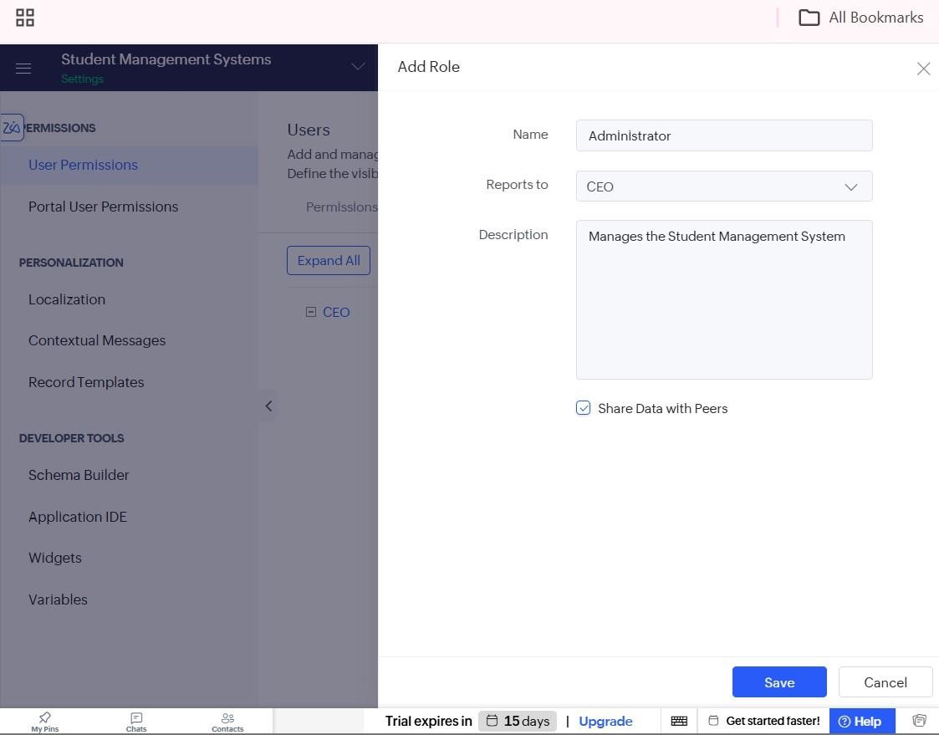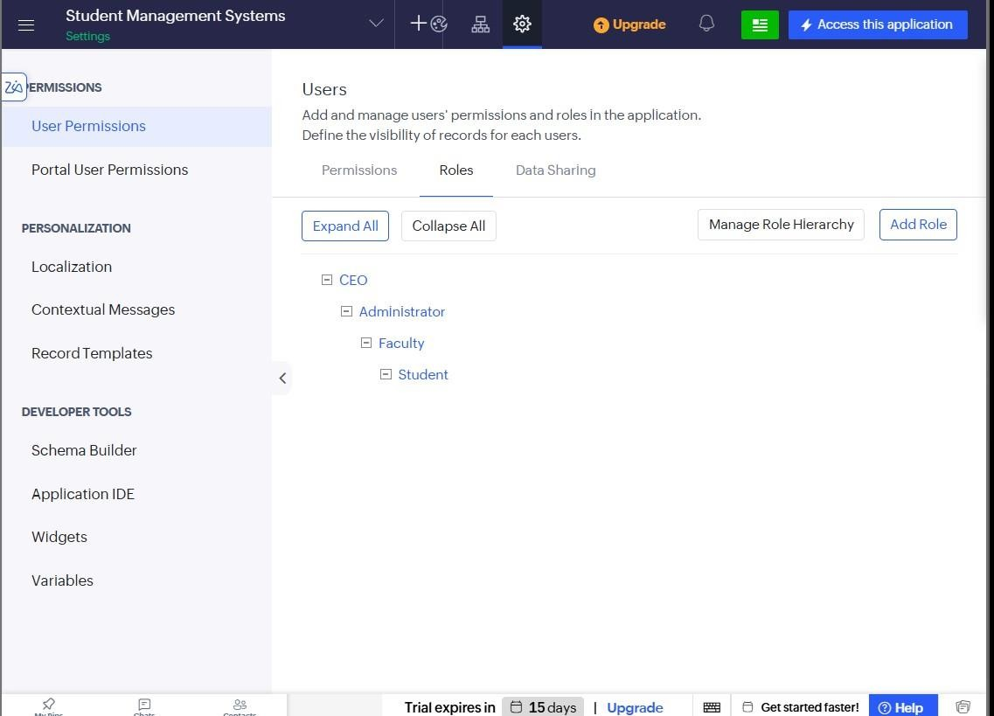
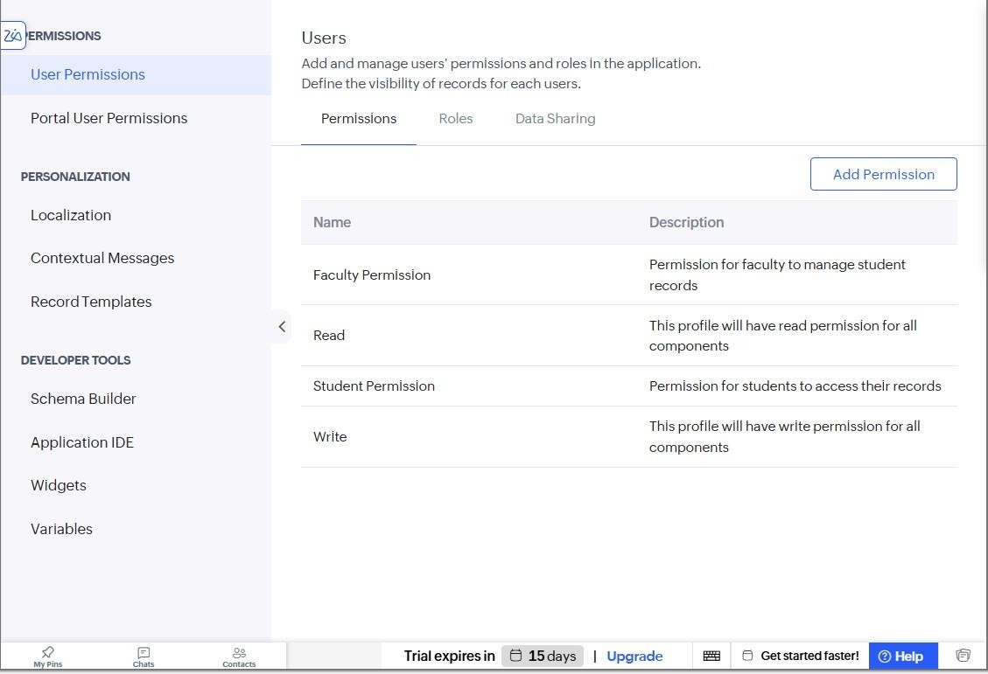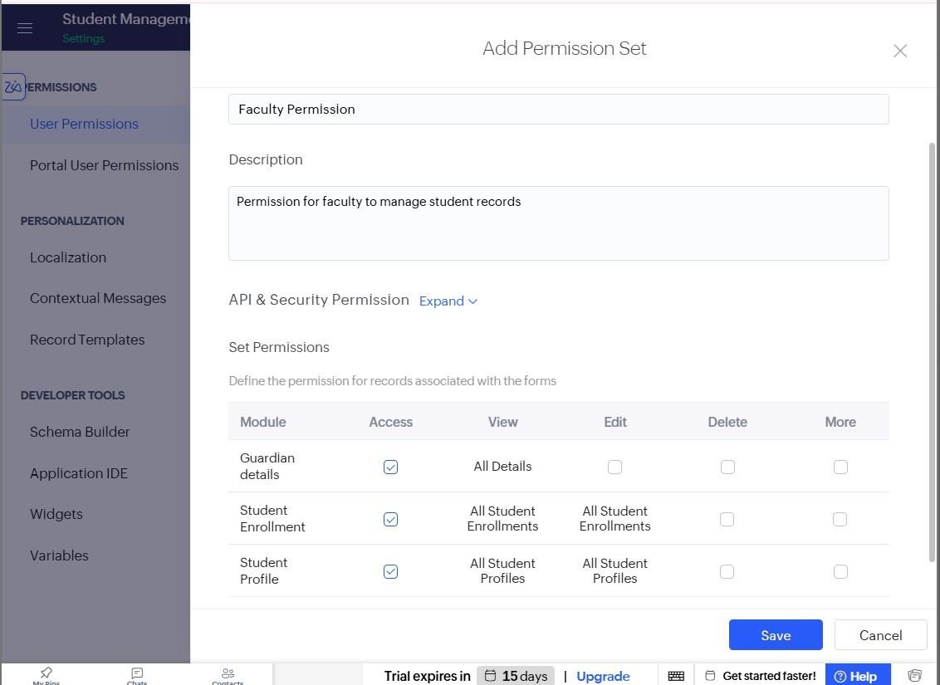
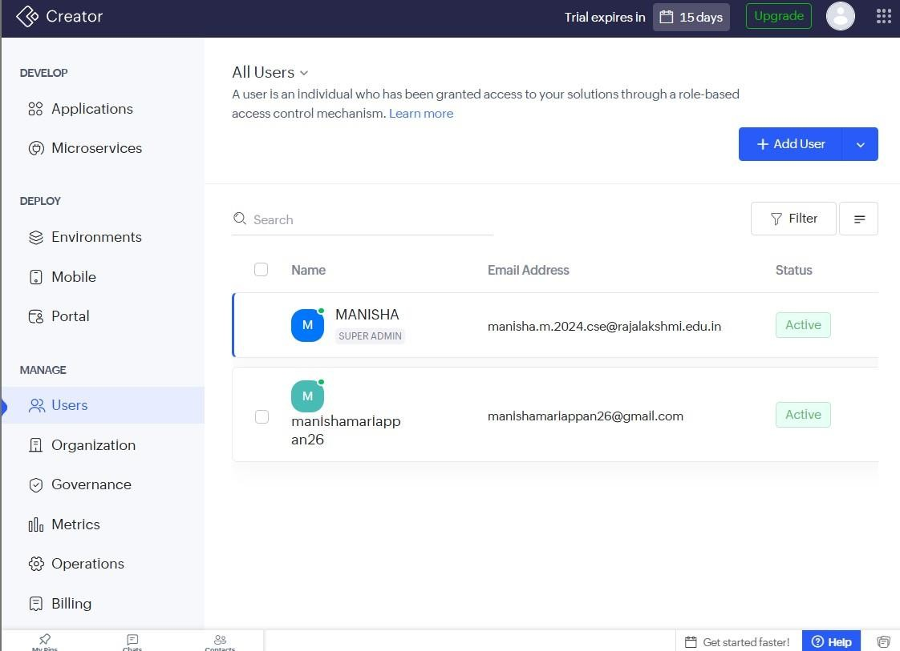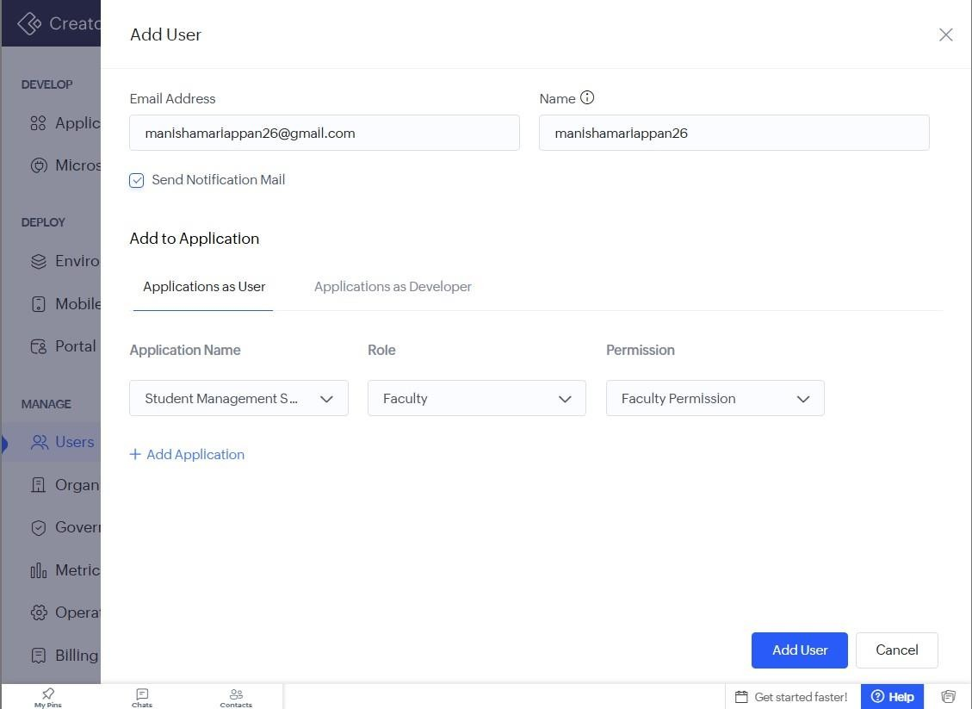

Result
Thus, different user roles and permissions were successfully created and configured in Zoho Creator to control access to the Student Management System.

